Truck website requirements + wish list

1 Back end

  - Rate Design

The concept of setting up rates should follow the rate definition on Maestro and Rubicon.

Need to be able to define
- Location
- Pick up and drop off restrictions
- Length of rental (minimum days and maximum days)
- Whether or not the rate is discountable*
- Applicable truck classes
- Number of free kilometers for the rate (only three choices: 0 free km, 50 free km, 100 free km)
- Km charge for each truck class (like in the Vehicle Rate Maintenance screen)
- This is necessary because some business/production accounts offer different mileage charge for different vehicle classes (like the BLUE rate)

Refer to Deborah’s sample (truck rate structure.xls) for more details.

* On budget.com, a discountable rate is applied when (i) a BCD is used and the discount is applied on a marked up rack rate or (ii) when a repeat customer makes a booking using his/her online ID through the Rent More, Save More promotion
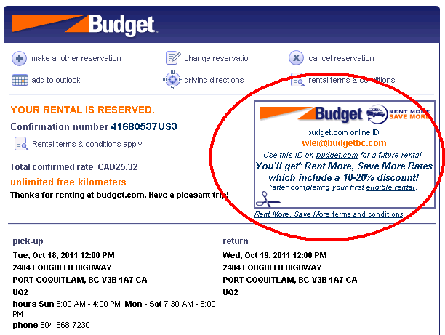

  - Rate Calculation

All rates, regardless of the length of rental (block, days, weeks, month), will need to be locked down. This feature should behave similarly to the Voucher concept where no refunds are applicable for early returns.

Implement cumulative rates (like Geordy’s website)
- on top of that, the website should allow be able to apply both a truck block and daily rate in a reservation
- 2 blocks should automatically become 1 day
- best buy will not apply
(e.g. if the rate for two blocks is cheaper than the daily, the daily rate will still kick in)

Implement new count down rates to promote weekday truck rentals (i.e. return Thursday)
E.g. If renter picks up on Monday, then he has up to 4 days to return the vehicle on Thursday
If renter picks up on Tuesday, then he has up to 3 days to return the vehicle on Thursday
If renter picks up on Wednesday, then he has up to 2 days to return the vehicle on Thursday
If renter picks up on Thursday, then he has up to 1 day to return the vehicle on Thursday
If renter picks up on Sunday, then he has up to 5 days to return the vehicle on Thursday

- Front end

The website should have two tabs – Personal and Commercial. This two rental types will be the main focus of Phase I of the website. The website will focus on package rates (round trips) in the next phase.

  - Personal

Time Selection

Time Block | Pick Up Time | Drop Off Time
AM | 07:30 | 11:30
PM | 12:00 | 16:00
OV | 16:30 | 07:00

Pick up Time will be restricted to three selections according to the table above (in a drop down list)
Drop off Time will be restricted to three selections according to the table above (in a drop down list)

Vehicle Class Selection
Drop down list. Basic truck classes for leisure. There is a difference in vehicle selection for Personal and Business use in budgettruck.com.

  - Commercial

BCD lookup
Website must prompt the user for a BCD number.
- If BCD number is invalid, user will be automatically redirected to the Personal tab.
- If BCD number is valid, user will be able to proceed to the next page to make bookings.

Time Selection
Drop down list. User will NOT be restricted to specific time selections.

Vehicle Class Selection
Drop down list. Trucks in the Personal category should be listed for commercial use. Should also display trucks with lift gate or power tail gate (e.g. T-1-Ton-PTG).

- To be Discussed

i. Package rates: Offer users the choice to select different days and different mileages for their rental needs (same idea as Geordy’s round trip)

ii. Do we make reservations made on the truck website commissionable? I.e. travel agents will be able to make bookings using their IATA number
→ This feature is available on budget.com

- References
US truck website - http://www.budgettruck.com/
Canada truck website - http://www.budget.ca/truck/en/

